1. What is the emissions per capita of Canada?

It is 17.72

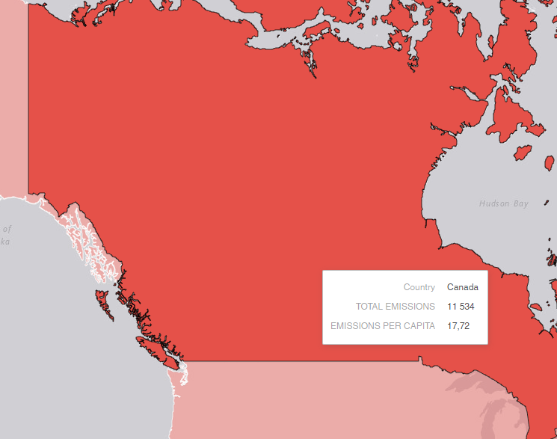

2. What is the overall trend in worldwide emissions?

Emissions are gradually increasing

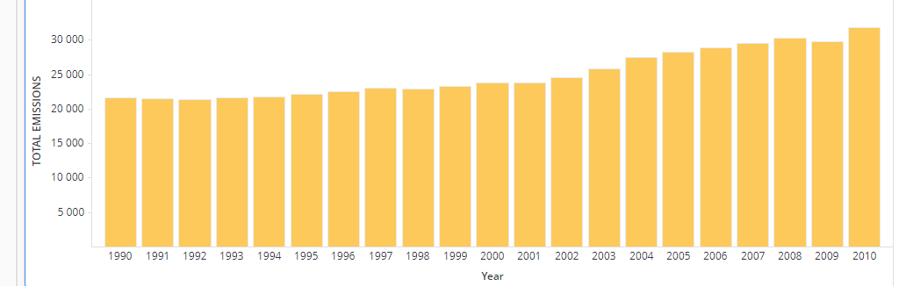

3. Notice that overall emissions declined in 2009, the only year in the total number of years surveyed that indicates emissions decreases in all three emissions sources. Why is that? What broader socio-political context might explain this single yearly decrease?

At 2008 happened world financial crisis which caused decreasing of energy consumption.